With over 30 years’ experience here at Caledonian Plywood, we pride ourselves in the service and quality we offer to our customer base across the length and breadth of the country
As well as supplying Plywood, we also offer an extensive range of high performance fire rated doors and door sets in a range of weights and finishes. Fire doors are built to a superior standard and as an environmental option we can offer full FSC® Certification if requested on most of our bespoke products.

We are now happy to advise that as well as providing you with our plywood, we can also offer a complete cutting service* for our customers at our Uddingston Manufacturing Unit using our new beam saw.

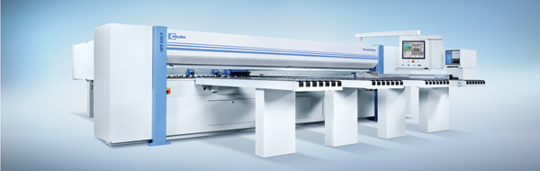

Precise and accurate cutting service now offered saving you time and hassle, either as a one off or a high-volume job.

PLYWOOD, MDF OR CHIPBOARD – Cut to any size*!

Contact: Ian Stewart (Manufacturing Manager) or our sales staff on: 01698 811666, fill out the enquiry form below or alternatively email your enquiry to: Ian.s@cpcply.co.uk or sales@cpcply.co.uk

* Minimum order value and quantity may be applicable. Carriage charge may apply if delivery is required.
Enquiry Form

Contact details
Name: | Company:
Position: | Type of business:
Phone: | Email:

Products/services most interested in

☐ Fire Doors ☐ Sheet Materials ☐ Sheet Material Cutting Service

Requirements
……………………………………………………………………………………………………....................................................
……………………………………………………………………………………………………....................................................
……………………………………………………………………………………………………....................................................

Next steps
☐ Email information ☐ Send quote ☐ Call to arrange appointment

Additional Comments/Enquiries
……………………………………………………………………………………………………...................................................
……………………………………………………………………………………………………...................................................

